**Working with s3 buckets**

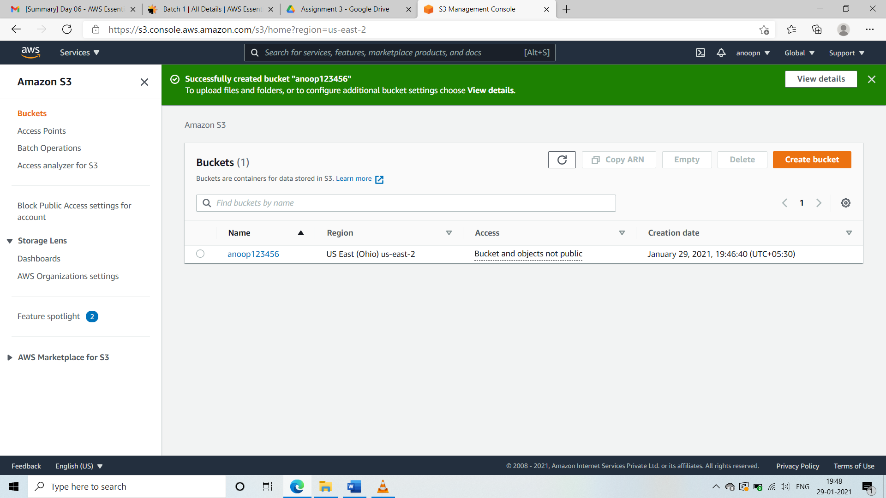

**SS1: Task 1: Create a bucket**

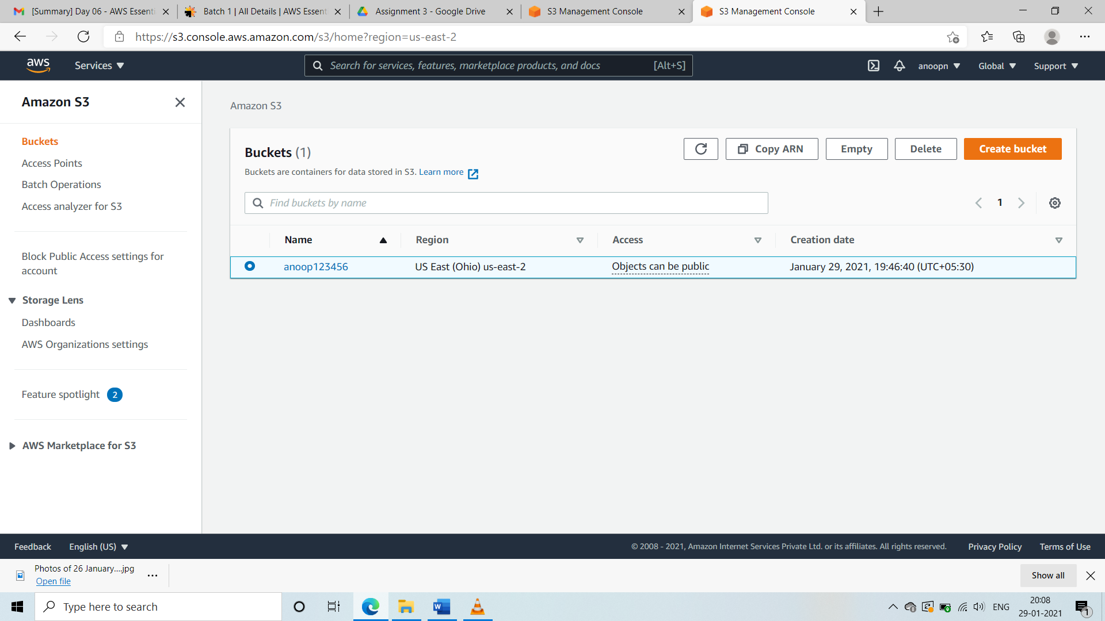

**SS2:Task 2:Add objects into the bucket and make it public.**

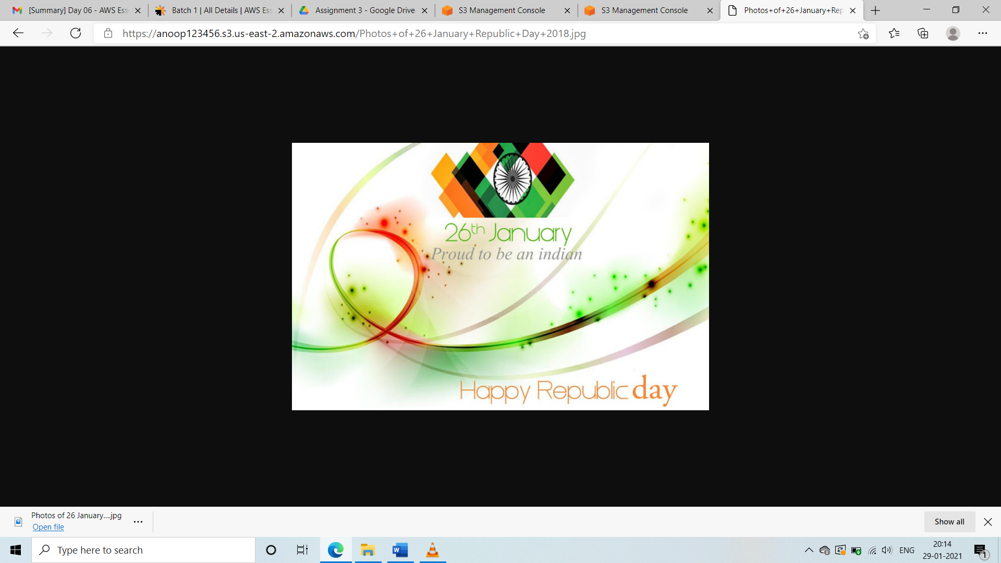

**SS3 : Task 3:Try to access an object using URL**